**Task 4: Deploy a Serverless Function to the Cloud  
  
Objective :-  
  
To understand serverless computing by creating and deploying a simple cloud function (FaaS) that executes code automatically when triggered — without managing any servers.**Step 1 :- Create the Lambda Function

* Log in to the AWS Management Console.
* Search for Lambda and click Create function.
* Choose Author from scratch.
* Enter a function name (Task_4)
* Runtime: Select Python 3.x (or any language you prefer).
* 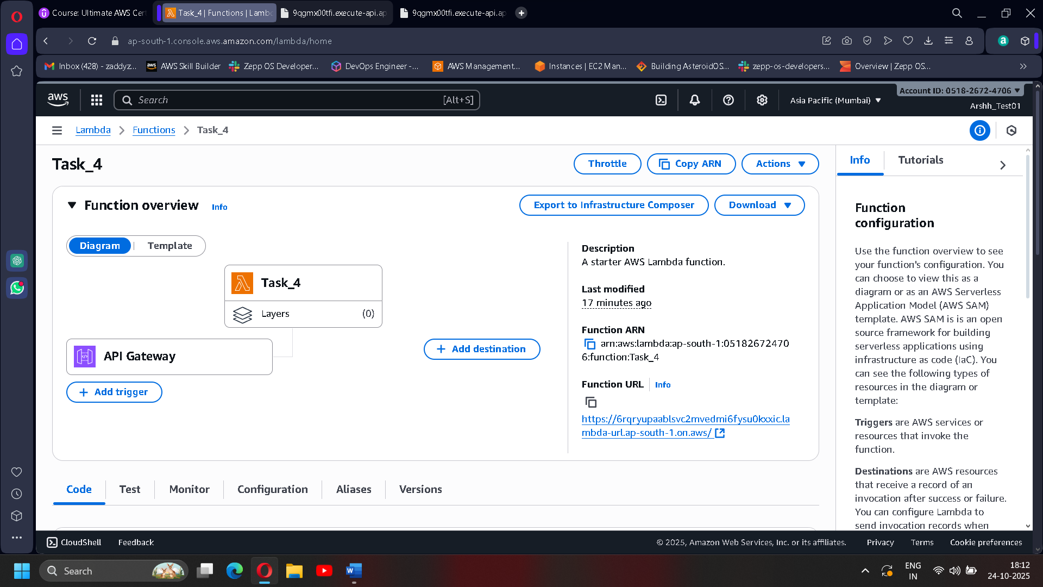Click Create function and wait for the success message.

**Step 2 :- Add the Function Code**

* Scroll to the **Code** section.
* Replace the default code with a simple test function, like printing “Hello from Lambda!”.
* 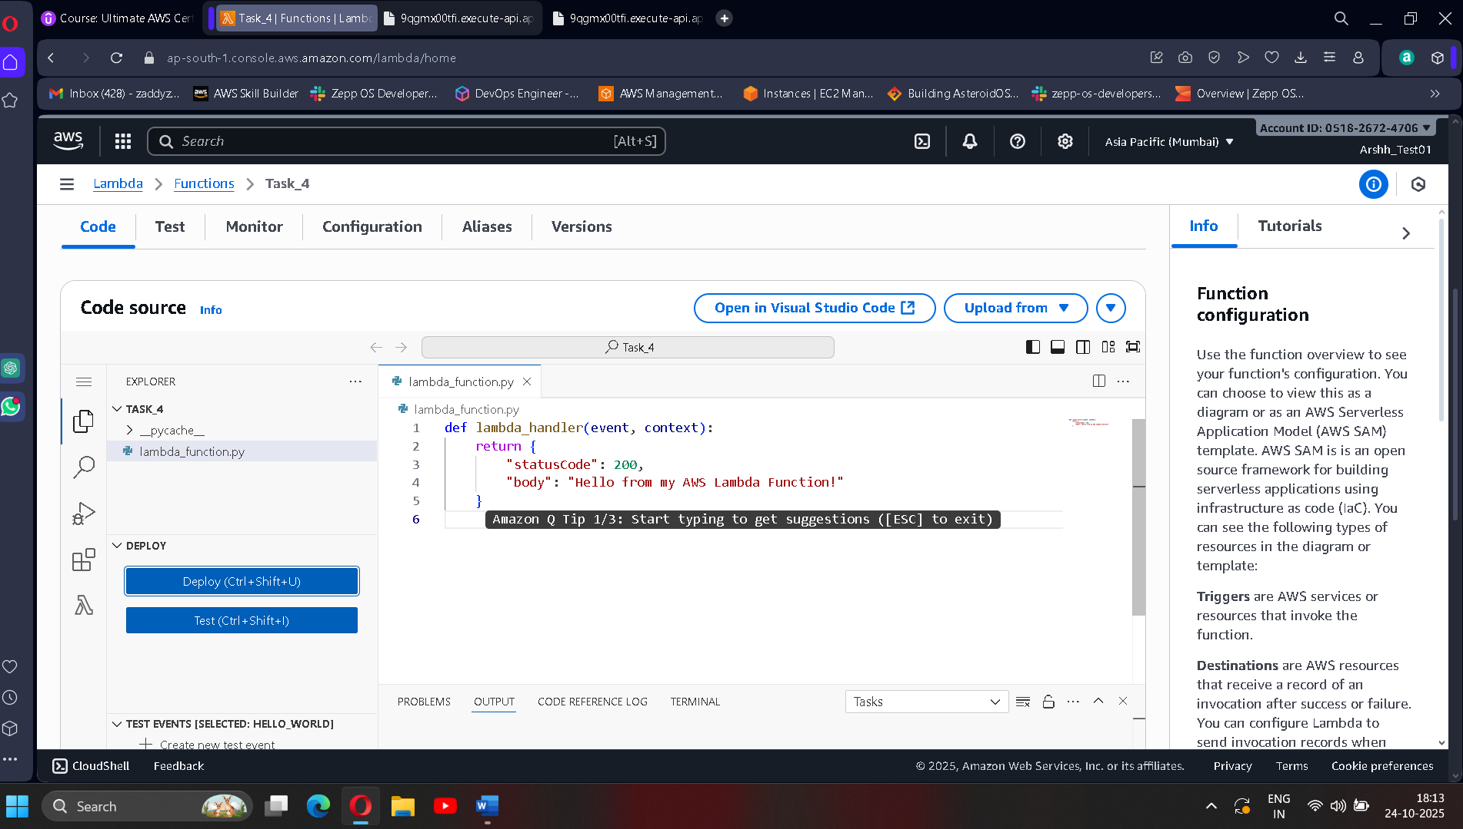Click **Deploy** to save the changes.

**Step 3 :- Configure a Trigger (Invoke Automatically)**

Choose how your Lambda gets activated:

* 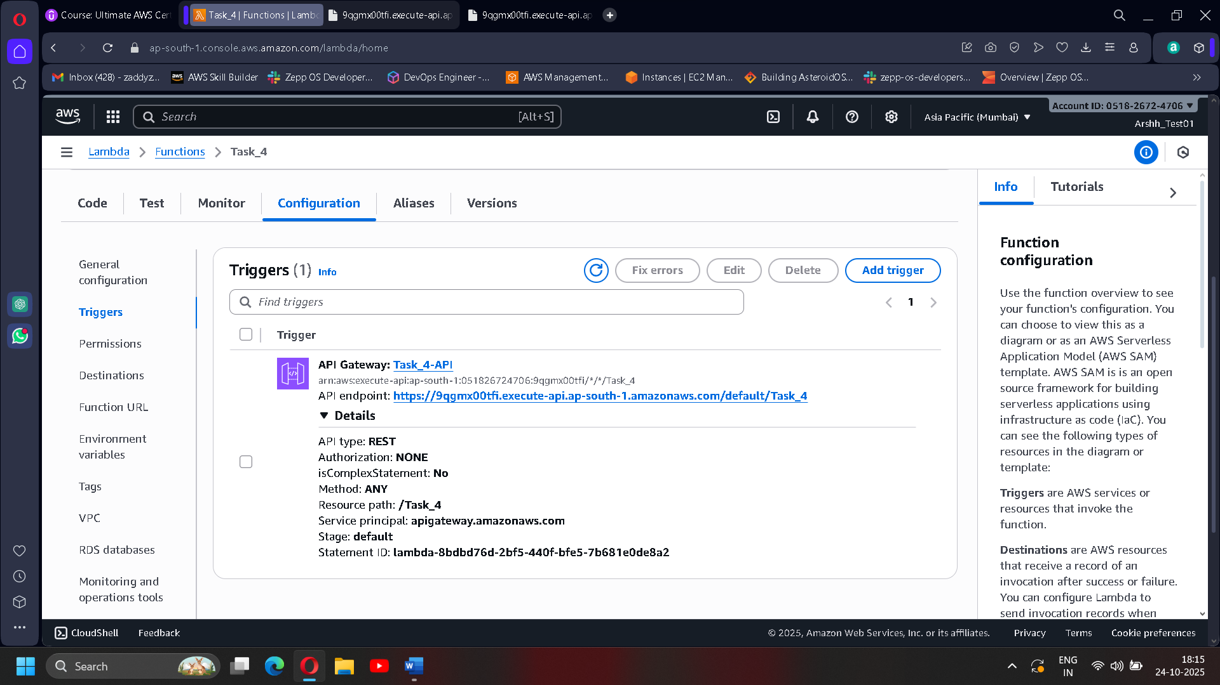**API Gateway**: For an HTTP trigger (access via web browser)

**Step 4 :- Test the Function**

* In the Lambda console, click **Test**
* Create a new test event with default JSON
* Click **Invoke**
* 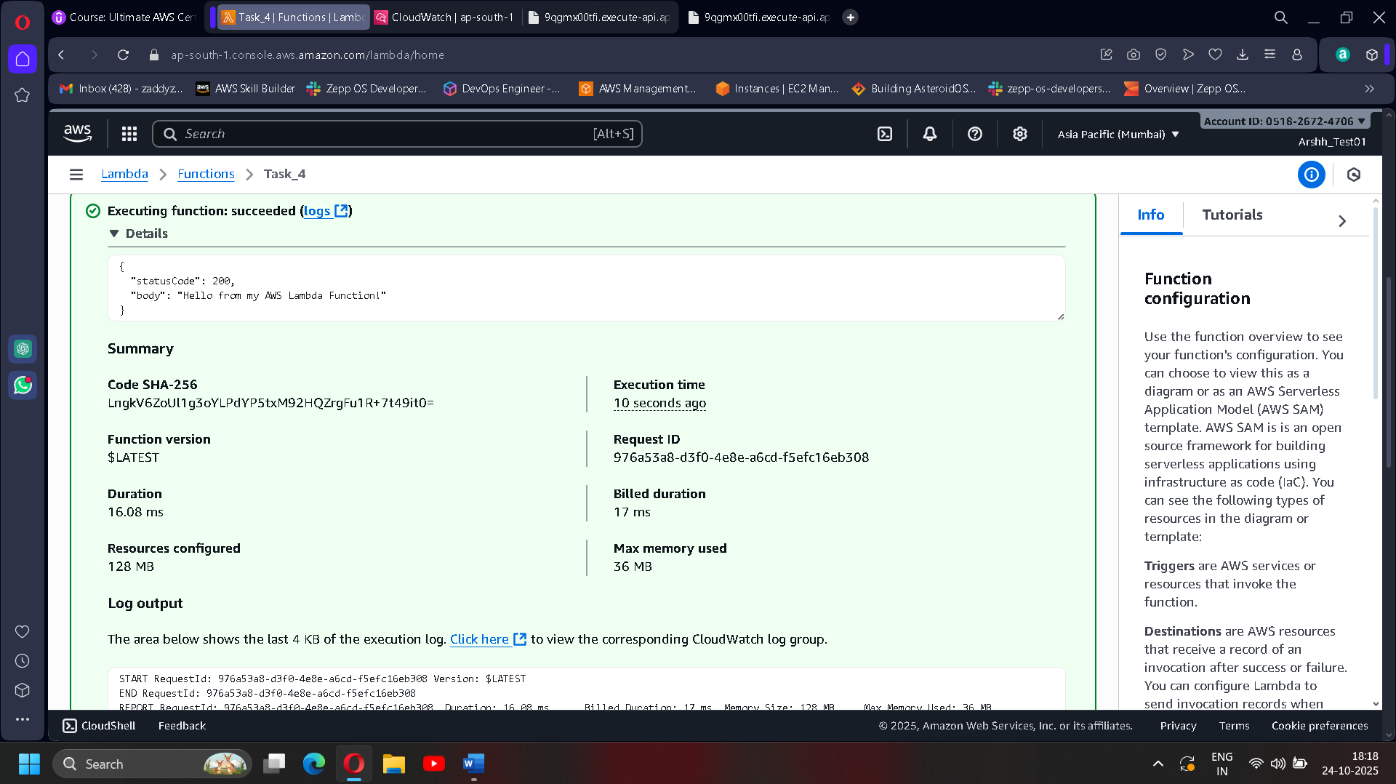Check the results and logs

**Step 5 :- Test the Function Through Your Browser (HTTP URL)**

1. After adding the **API Gateway** trigger, go to the **Triggers** tab in your Lambda function.
2. You will find an **Invoke URL** generated by API Gateway. It looks like:  
   <https://9qgmx00tfi.execute-api.ap-south-1.amazonaws.com/default/Task_4>
3. Copy this URL.
4. Open your web browser.
5. Paste the URL into the address bar and hit Enter.

